**Vivekanand Education Society’s Institute**

**Of Information Technology**

Collector Colony, Kurla (East),

Mumbai – 400074, Tel: 91-22-261532532



**A Project Report**

**On**

**“Flying Aeroplane”**

**Submitted By**

**Ninad Patil (Roll No 33)**

**Sarath Shankaranarayanan (Roll No 41)**



**(Computer Graphics & Soft Skill Development Lab)**

**MINI PROJECT**

**CERTIFICATE**

This Mini Project duly signed in this Documentation represents the bonafide works by:

**NAME: NINAD A PATIL ROLL NO: 33**

**NAME: SARATH SHANKARANARAYANAN ROLL NO: 41**

For SEMESTER - IV of Second Year of the Master in Computer Application (MCA) [Afternoon Shift] in the Computer Laboratory of this College during the academic year 2020- 2021

**Lecturer In-Charge Head, Department of MCA**

**Lab Incharge External Examiner**

**ACKNOWLEGEMENT**

It is in good fortune that we find the opportunity to express our deep sense of gratitude to all those people who helped us with their guidance and assistance without which this project would not be possible.

The successful completion of any task would be incomplete without the mention of those people whose cooperation made it possible, whose constant guidance and encouragement crown all our efforts with success.

We would like to give our heartiest thanks to the Project guide, **Prof. DASHRATH MANE AND Prof. RAMESH SOLANKI** giving us their precious time, incessant encouragement, and for their valuable advice and guidance without which this project would not have seen the light of day.

We also thank our group members and colleagues who have helped in the successful completion of this project. And last but not least, we would like to thank all those who contributed to this project either morally or materially. Thank you all.

**INDEX**

|  |  |  |
| --- | --- | --- |
| **Sr. No** | **Topic** | **Remark** |
| 1 | Introduction |  |
| 2 | Hardware & Software Requirements |  |
| 3 | Code |  |
| 4 | Screenshot |  |
| 5 | Conclusion |  |
| 6 | Reference |  |

**INTRODUCTION**

**Project Name:** Flying Aeroplane

**Aim:**

Implementation of Flying Aeroplane using C++.

**Description:**

“Flying Aeroplane” is a C++ project to demonstrate about how the aeroplane is flying. The aim of this project is to demonstrate and guide the airplane until it fully takeoff. It will also display buildings in the runway.

In this project we have used some algorithm like ellipse, line and rectangle.

**ellipse ():** Ellipse is defined as the locus of a point in a plane which moves in a plane in such a manner that the ratio of its distance from a fixed point called focus in the same plane to its distance from a fixed straight line called directrix is always constant, which should always be less than unity.

**line ():** In graphics, a line can be described as a single point that continues for a distance, or as the connection between two points. The purpose of a line in graphics is to help the artist to communicate to the viewers what it is they are supposed to be seeing or taking notice of.

**rectangle ():** Coordinates of left top and right bottom corner are required to draw the rectangle. left specifies the X-coordinate of top left corner, top specifies the Y-coordinate of top left corner, right specifies the X-coordinate of right bottom corner, bottom specifies the Y-coordinate of right bottom corner.

**The project has been developed using ‘C++’**

**HARDWARE/SOFTWARE REQUIREMENTS**

**HARDWARE REQUIREMENT**

* Intel(R) Core (TM) 2 Duo E7500 CPU @ 2.93GHz
* 1 GB RAM
* 10 GB Hard Disk

**SOFTWARE REQUIREMENT:**

* **Operating System:** Windows 7 or higher
* **Software Used:** Turbo C++
* **Programming Language:** C++

**CODE**

#include<conio.h>

#include<graphics.h>

#include<dos.h>

void main()

{

int gd=DETECT,gm,i=0;

initgraph(&gd,&gm,"C://TURBOC3//BGI");

for(i;i<600;i++)

{

line(80+i,300-i,250+i,300-i);

line(150+i,340-i,200+i,340-i);

line(150+i,340-i,100+i,400-i);

line(200+i,340-i,100+i,400-i);

line(80+i,380-i,115+i,380-i);

line(132+i,380-i,250+i,380-i);

ellipse(250+i,340-i,270,90,80,40);

line(100+i,270-i,150+i,300-i);

line(100+i,270-i,200+i,300-i);

line(80+i,300-i,65+i,260-i);

arc(80+i,340-i,180,270,40);

line(40+i,340-i,40+i,260-i);

line(40+i,260-i,65+i,260-i);

ellipse(250+i,338-i,10,81,70,30);

line(261+i,333-i,320+i,333-i);

line(261+i,333-i,261+i,310-i);

rectangle(100+i,310-i,120+i,330-i);

rectangle(130+i,310-i,150+i,330-i);

rectangle(160+i,310-i,180+i,330-i);

rectangle(190+i,310-i,210+i,330-i);

rectangle(220+i,310-i,240+i,330-i);

line(0,459,679,459);

rectangle(510-i,459,550-i,430) ;

rectangle(550-i,459,610-i,430);

line(530-i,410,550-i,430);

line(530-i,410,510-i,430);

line(590-i,410,610-i,430);

line(590-i,410,530-i,410);

rectangle(430-i,430,490-i,459);

rectangle(390-i,430,430-i,459);

line(410-i,410,430-i,430);

line(410-i,410,390-i,430);

line(410-i,410,470-i,410);

line(470-i,410,490-i,430);

delay(5);

cleardevice();

}

getch();

}

**SCREENSHOT**

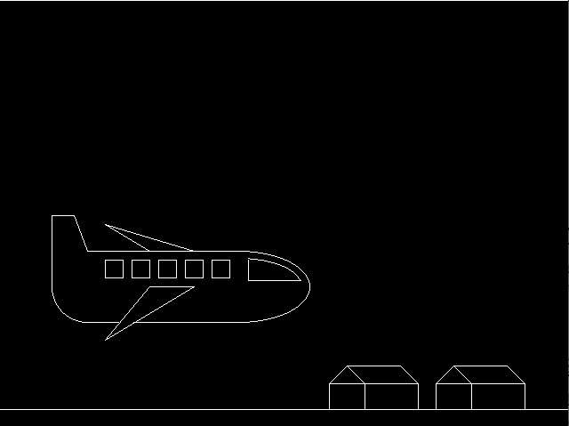

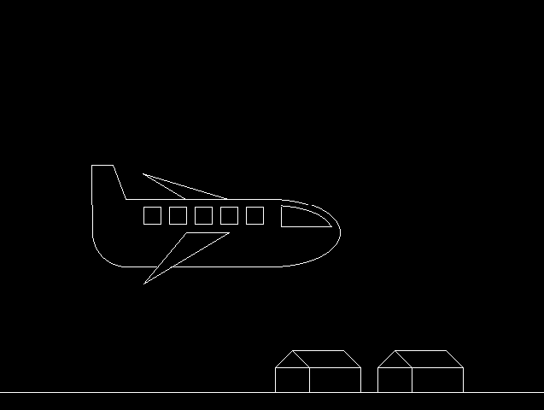

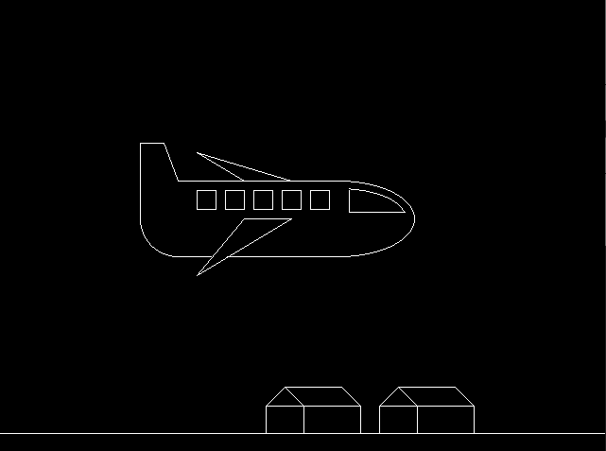

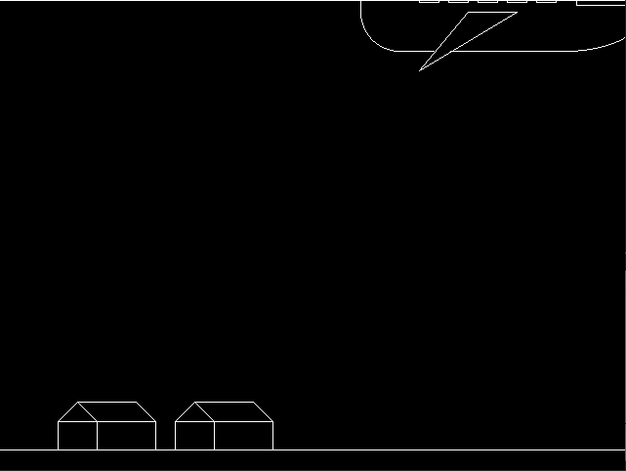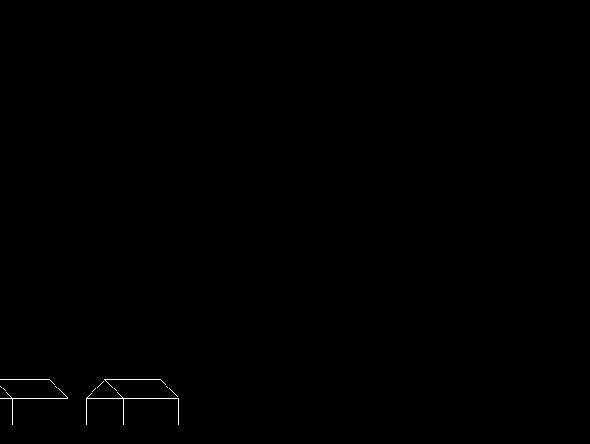

**CONCLUSION**

* So, we have created a project based on C++ and graphics library.
* We have tested this project we are getting is in good accuracy.
* It is simple project which demonstrate the flying of an aeroplane.
* The development of this project has enabled us to improve the graphics and problem solving which will helps us to make more graphics related project in future.

**REFERENCE**

**Web Reference:**

* <https://www.geeksforgeeks.org/computer-graphics-2/>
* <https://www.geeksforgeeks.org/include-graphics-h-codeblocks/>

**Textbook Reference:**

* The Complete Reference C++ Fourth Edition by Herbert Schildt.
* The C++ Programming Language by Bjarne Stroustrup.